P1 – static route

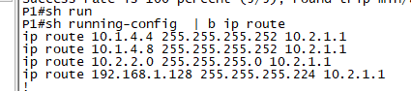

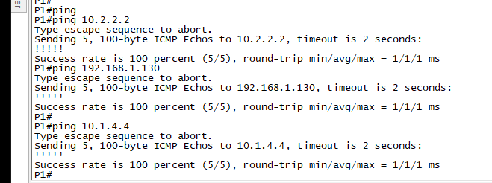

P2 – default route



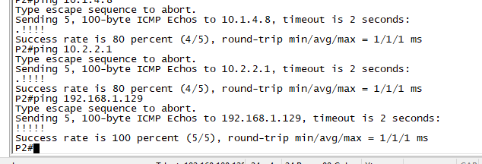

EIGRP

**R4 – reaching 10.2.1.0/30 | 10.2.2.0/30 | 192.168.1.0/27**

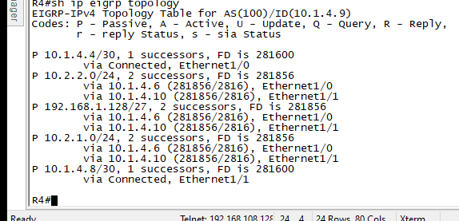

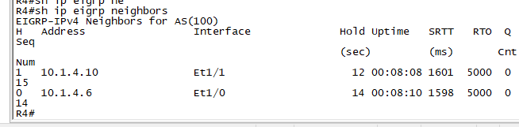

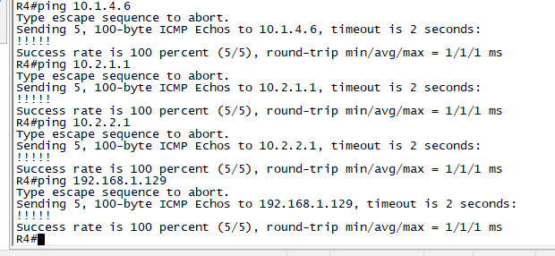

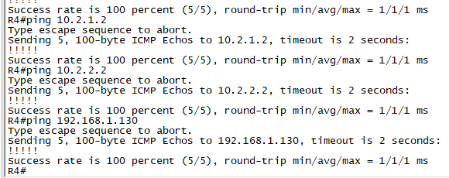

OSPF

R3 – R2 backbone

OSPF neighbor

R3

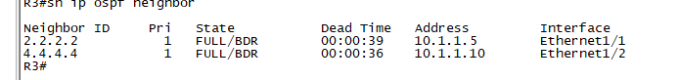

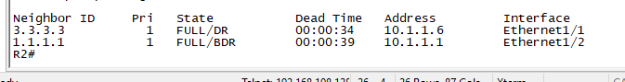

R4 reaching R1 – 10.1.1.1

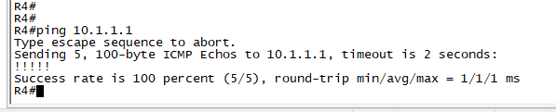

P1 -

int e0/0

ip add 10.2.1.101 255.255.255.0

no shut

P2

int e1/0

ip add 10.2.1.102 255.255.255.0

no shut

allow subnet 10.1.4.6 255.255.255.252 to P1

10.2.2.0 /24 to P1

192.168.1.128 255.255.255.224 to P1

default route

ip route 0.0.0.0 0.0.0.0 10.2.1.2

EIGRP

question what is route bit in eigrp

TASK: configure 64bit eigrp on D1/D2: CCNP and 32bit on R4: CCNA

how to configure eigrp:

route the network:

rule: first check all connected network routes

- sh ip route | inc

D1

convert to wild card

10.1.4.4/30 -> 10.1.4.4 0.0.0.3

10.2.1.0/24 -> 10.2.1.0 0.0.0.255

10.2.2.0/24 -> 10.2.2.0 0.0.0.255

192.168.1.128/27 -> 192.168.1.128 0.0.0.31

then create a route anme

router eigrp biteigrp

address-family ipv4 unicast autonomous-system 100

network 10.1.4.4 0.0.0.3

network 10.2.1.0 0.0.0.255

network 10.2.2.0 0.0.0.255

network 192.168.1.128 0.0.0.31

D2

router eigrp biteigrp

address-family ipv4 unicast autonomous-system 100

network 10.1.4.8 0.0.0.3

network 10.2.1.0 0.0.0.255

network 10.2.2.0 0.0.0.255

network 192.168.1.128 0.0.0.31

R4 32 bit (ccna)

10.1.1.8/30 -> 10.1.1.8 0.0.0.3

10.1.4.4/30 -> 10.1.4.4 0.0.0.3

10.1.4.8/30 -> 10.1.4.8 0.0.0.3

router eigrp 100

no auto-summary

network 10.1.4.4 0.0.0.3

network 10.1.4.8 0.0.0.3

check eigrp is running

show ip eigrp traffic

show ip eigrp topology

show ip route eigrp

show ip protocols

show ip eigrp neighbors

TASK 3: Open shortest path first protocol ( OSPF ): the most supported protocol in routers

will be using - MULTI AREA OSPF

route all connected device in that router and identify the area.

1. Create your areas

= 0 backbone

2. Create virtual ip address for stability and for diagnostic / tagging purposes as well as as OSPF requirement.

R4 - 10.1.1.8/30

int lo0

ip add 4.4.4.4 255.255.255.255

router ospf 1

router-id 4.4.4.4

network 10.1.1.8 0.0.0.3 area 34

R3

- 10.1.1.8/30

- 10.1.1.4/30

int lo0

ip add 3.3.3.3 255.255.255.255

router ospf 1

router-id 3.3.3.3

network 10.1.1.8 0.0.0.3 area 34

network 10.1.1.4 0.0.0.3 area 0

R2

- 10.1.1.0/30

- 10.1.1.4/30

int lo0

ip add 2.2.2.2 255.255.255.255

router ospf 1

router-id 2.2.2.2

network 10.1.1.0 0.0.0.3 area 12

network 10.1.1.4 0.0.0.3 area 0

R1

- 10.1.1.0/30

int lo0

ip add 1.1.1.1 255.255.255.255

router ospf 1

router-id 1.1.1.1

network 10.1.1.0 0.0.0.3 area 12

how to check ospf is working

show ip protocols

show ip ospf database

show ip ospf neighbours

show ip route ospfs